Power Demand Analysis

The proposed coal-fired power plant has a capacity of 500 MW to be located at Lian, Batangas. The electricity that will be generated will be transmitted to the Luzon Grid of the National Grid Corporation of the Philippines (NGCP).

According to Department of Energy, the forecasted total System Peak Demand for Luzon is 12,285 MegaWatts (MW) to occur in May 2020 which is an increase of 8.3% from the actual 2019 peak demand of 11,344 MW which occurred in the dry season months of the country. In order to stabilize the grid in the coming year, the Luzon Grid needs around 4% of the peak demand which is around 491 MW in regulating power. As the consumers shift in the way of the usage of power, it needs to maintain the power equivalent in order to support the grid in case of emergencies.

The table below shows the actual peak demand of 2019 and Forecast Peak Demand of 2020 in the Luzon, Visayas and Mindanao grids.

Table

Actual and Forecast Peak Demand

|  |  |  |
| --- | --- | --- |
| GRID | 2019 Actual Peak Demand | 2020 DOE Forecast Peak Demand |
| Luzon | 11,344 MW (June) | 12,285 MW (May) |
| Visayas | 2,224 MW (May) | 2,419 MW (May) |
| Mindanao | 2,103 MW (May) | 2,278 MW (December) |

Source: ngcp.ph

From the table above, it can be seen that there is an increase in the demand of the consumers since the way people use the electricity changer. The Department of Energy forecasted an increase of 8.3% of the 2019 Actual Peak Demand which is about 941 MW. In addition, electricity demand goes higher in dry season months such as May and June. For the 2020 Forecast Peak Demand of the Department of Energy, it is observed that the Luzon, Visayas and Mindanao Grids will have a total peak demand of 16,982 MW.

The table below presents the electric generation and consumption of different types of distribution utilities in Luzon, Visayas and Mindanao. The power consumption are listed by sector which includes residential, commercial, industrial and other sectors.

Table

2018 Electric Generation and Consumption in MWh

|  |  |  |  |  |
| --- | --- | --- | --- | --- |
| Type of Distribution Utilities | Luzon | Visayas | Mindanao | Philippines |
| Power Consumption by Sector | | | | |
| Residential | 20,557,265 | 3,863,595 | 3,839,904 | 28,260,764 |
| Commercial | 20,691,045 | 1,704,677 | 1,620,548 | 24,016,270 |
| Industrial | 19,352,877 | 3,978,020 | 4,256,451 | 27,587,348 |
| Others | 940,124 | 1,285,120 | 527,474 | 2,752,719 |
| Total Sales | 61,541,312 | 10,831,413 | 10,244,377 | 82,617,102 |
| Own-Use | 5,668,573 | 1,485,306 | 987,157 | 8,141,036 |
| System Loss | 6,293,025 | 1,175,228 | 1,538,327 | 9,006,580 |
| Total Consumption | 73,502,911 | 13,491,947 | 12,769,861 | 99,764,718 |

Source: doe.gov.ph

According to the table above, the consumption of Luzon grid soared to 73,502,911 MWh for 2018 wherein residential sector contributed 82.15% of the total power consumption of the sectors. The industrial sector has been increasing since a lot of programs in the industry are continuously driven. Comparing the 2017 generation, the residential sector marks a growth of 5.5% in 2018 from 4.5% in 2017.

The table below shows the system peak demand in MW of the three grids. The data gathered is around the year of 2018 and listed by month showing which time do consumers have the highest demand of electricity.

Table _

2018 Monthly System Peak Demand in MW

|  |  |  |  |
| --- | --- | --- | --- |
| Month | Luzon | Visayas | Mindanao |
| January | 9,213 | 1,892 | 1,665 |
| February | 9,579 | 1,913 | 1,704 |
| March | 9,936 | 1,956 | 1,729 |
| April | 10,539 | 2,044 | 1,781 |
| May | 10,750 | 2,053 | 1,847 |
| June | 10,876 | 2,010 | 1,741 |
| July | 9,996 | 1,972 | 1,762 |
| August | 9,843 | 2,015 | 1,821 |
| September | 10,035 | 1,954 | 1,794 |
| October | 10,346 | 2,026 | 1,835 |
| November | 10,088 | 1,980 | 1,833 |
| December | 9,987 | 2,020 | 1,853 |
| MAX | 10,876 | 2,053 | 1,853 |

Source: doe.gov.ph

From the table above, it shows that Luzon and Visayas grid has the highest system peak demand in dry months. In Luzon, the system peak demand is seen in the month of June which has 10,876 MW on which the country’s temperature is at its maximum while the month of January has the lowest system peak demand of 9,213 MW. In Visayas, the highest peak demand was experienced in the month of May at 2,053 MW while in Mindanao , the month of December experienced a highest peak demand of 1,853 MW.

Upon observing, the demand of the consumers has been continuously increasing as the temperature in the country is changing. The proposed design of the coal-fired power plant has a capacity of 500 MW which will be transmitted to Luzon grid of the National Grid Corporation of the Philippines for further distribution.

**Power Demand and Supply Balance**

In the Philippines, power demand of consumers in different sectors such as residential, commercial and industrial has been increasing rapidly. Emergencies in Luzon grid are also experienced in the year 2019 that cause power interruptions in some areas of Luzon. In order to stabilize the grid, increasing demand of electricity must be regulated to avoid brownouts.

Below is the list of sources of fuel that are used in power generation in the year 2018. Power generation is in GWh unit.

Table _

Power Generation by Source in GWh (2018)

|  |  |
| --- | --- |
| **Source** | **Power Generation** |
| Coal | 51,932 |
| Oil-Based | 3,173 |
| Combined Cycle | 522 |
| Diesel | 2,505 |
| Gas Turbine | 0 |
| Oil Thermal | 145 |
| Natural Gas | 21,334 |
| Renewable Energy | 23,326 |
| Geothermal | 10,435 |
| Hydro | 9,384 |
| Biomass | 1,105 |
| Solar | 1,249 |
| Wind | 1,153 |
| TOTAL | 99,765 |

Source: doe.gov.ph

From the table above, it can be observed that coal dominated the power generatio in the Luzon grid with 51,932 GWh which is about 52.05% of the total power generated. Some of the sources include oil based that may be combined cycle, diesel, gas turbine and oil thermal, natural gas and renewable energies such as geothermal, hydro, biomass, solar and wind. The total generated power in 2018 was 99,765 GWh.

Below is the table of summary for the power generation in Luzon, Visayas and Mindanao grid in the year 2018.

Table _

Summary of Power Generation by Grid in GWh (2018)

|  |  |
| --- | --- |
| Grid | Power Generated |
| Luzon | 72,728 |
| Visayas | 14,266 |
| Mindanao | 12,770 |
| TOTAL | 99,765 |

In Region IV-A, there are eight (8) distribution utilities excluding MERALCO which includes QUEZELCO II, BATELEC II, FLECO, QUEZELCO I, BATELEC I, FBPC and IEC. The table below shows the peak demand in some distribution utilities in Region IV-A.

Table _

Region IV-A Peak Demand

|  |  |
| --- | --- |
| Distribution Utility | Peak Demand (MW) |
| BATELEC I | 57.43 |
| BATELEC II | 136.00 |
| FBPC | 9.88 |
| IEC | 4.06 |
| TOTAL | 207.37 |

The table above shows that BATELEC II is the distribution utility in the listed four (4) distribution utilities has the highest peak demand at 136 MW. The total peak demand of the listed distribution utilities is 207.37 MW. The figure below shows the supply-demand forecasted for 2016 to 2026.

Figure _

Batangas II Electric Cooperative Inc. (BATELEC II) Supply-Demand

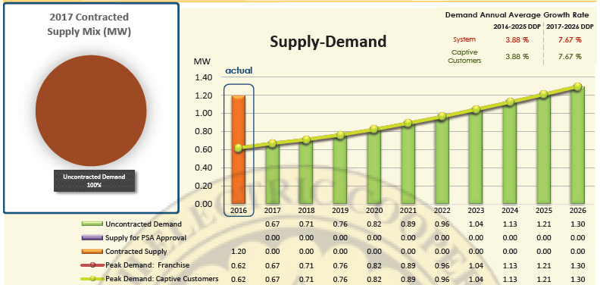

Source: doe.gov.ph

The figure above shows the increase of demand of captive customers in the following years. For the demand annual average growth rate forecasted in 2017-1016, the system and captive customers have 7.67%. for the planning horizon, BATELEC II forecasted an AAGR of 7.67% peak demand for some areas. In terms of energy sales, BATELEC II sold 1,111.63 MWh in 2016. Over the 10-year planning period, the annual average energy sales is projected to grow by 7.50% from 1,288.20 MWh to 2,284 MWh in 2026.

According to Department of Energy, the forecasted peak demand in Region IV-A in the year 2020 is 347.65 MW equivalents to 2.03% of the total peak demand in Luzon. Furthermore, it is observed that the peak demand is increasing continuously from 347.65 MW in 2020 to 421.57 MW in 2025 which is 21.26% of the present peak demand.